Materials Today Communications — Revised Manuscript MTCOMM-D-26-03066R2

Comparative Analysis of Machine Learning Models for Engineering
Material Classification Using Explainable Artificial Intelligence
Appiah-Kubi Samuelᵃ, Okyere Adobea Rosalindaᵃ
ᵃ BSc Laboratory Technology, School of Physical Sciences, University of Cape Coast (UCC), Cape Coast, Ghana
Correspondence: appiahkubisamuel779@gmail.com | okyererosalinda@gmail.com
Manuscript ID: MTCOMM-D-26-03066 | Revision Round 2

Abstract
Classifying engineering materials automatically and accurately remains one of the persistent challenges in materials informatics, with practical consequences for materials selection, quality control, and database management. This study compares five supervised machine learning (ML) algorithms Random Forest (RF), Support Vector Machine (SVM), k-Nearest Neighbours (k-NN), Logistic Regression (LR), and Decision Tree (DT) applied to a unified, multi-class dataset of 3,443 engineering materials covering Iron Alloys (n = 1,288; 37.4%), Polymers (n = 1,070; 31.1%), and Steels/Metals (n = 1,085; 31.5%) — a source/provenance and processing-route grouping rather than a strict metallurgical classification — compiled from three publicly available engineering databases. Each entry was characterised by up to 14 mechanical, physical, and chemical composition features. Strict leakage-free preprocessing (median imputation and StandardScaler normalisation) was enforced using scikit-learn Pipeline objects. Hyperparameter optimisation was performed via exhaustive Grid Search with stratified 5-fold cross-validation (CV). All five models achieved 100% accuracy on the held-out test set; 5-fold CV confirmed robustness (RF and DT: 100.00±0.00%; SVM, k-NN, LR: 99.97±0.06%). To address reviewer concerns regarding the unusually high accuracy, two additional ablation experiments and a permutation importance analysis were conducted. Removing the five elemental compositional features left performance essentially unchanged (99.97–100.00% across all models), confirming these features are not responsible for the high accuracy. Restricting the feature set to only Density and Thermal Conductivity the only two properties genuinely measured for all three classes revealed an informative asymmetry: tree-based models (Random Forest, Decision Tree) and k-NN retained 98.98–99.27% test accuracy, while the linear/margin-based models degraded substantially (SVM: 89.99%; Logistic Regression: 86.65%), demonstrating that the full 14-feature model provides genuine, non-redundant discriminative information beyond these two dominant properties, particularly for linear classifiers. Single-feature permutation importance on the Random Forest, by contrast, registered a non-zero accuracy decrease for only Thermal Conductivity, with all twelve other features showing exactly zero individual importance a result of the model's 100% baseline test accuracy that indicates substantial feature redundancy rather than any one feature being indispensable. This finding is reported transparently and interpreted alongside the ablation and SHAP results rather than in isolation. Correlation analysis confirms the absence of extreme multicollinearity outside the physically expected Elastic–Shear Modulus relationship. Limitations of the study including the coarse class granularity, the heavy reliance on median imputation for polymer mechanical properties, and the absence of external validation are explicitly acknowledged. SHAP analysis identified Thermal Conductivity, Density, Elastic Modulus, Shear Modulus, and UTS as the five most influential features, providing physics-grounded interpretability consistent with established materials science principles.

Keywords: Machine learning; engineering materials; material classification; SHAP; explainable AI; Random Forest; SVM; mechanical properties; materials informatics; feature ablation; cross-validation

1. Introduction
Choosing and identifying the right engineering material whether an iron alloy, a steel, or a polymer sits at the heart of virtually every mechanical design and manufacturing decision [6]. For decades, engineers have relied on standardised testing, expert knowledge, and tools like Ashby selection charts to make these judgements [2, 3]. These methods are effective, but they are slow, demand specialist expertise, and cannot keep pace with the scale and variety of material data now held in modern digital databases.
Beyond structural applications, the accurate classification of engineering materials is equally critical for the development of functional devices. Nanocomposite materials such as hard–soft Sr₀.₅Ba₀.₅SnₓFe₁₂₋ₓO₁₉/CoFe₂O₄ systems have demonstrated promising magnetic and electromagnetic properties that position them as candidate materials for wireless devices used in transmitting and analysing digital information [S1]. Reliable automated classification tools are therefore essential not only for structural material selection but also for screening functional materials across diverse application domains.
Machine learning (ML) offers a different path forward [5, 18, 10, 22]. Rather than depending on a human expert to interpret test results, ML algorithms learn directly from data identifying complex, non-linear relationships between material properties and class labels. ML models have also been applied to modelling and solving optimisation problems in materials processing; computational analyses of CdCl₂-containing CdTe films produced by discrete vacuum thermal evaporation have revealed complex morphology–structure relationships [S2] that benefit from data-driven modelling. Researchers have successfully used ML to predict the mechanical behaviour of steels [27], sort polymer types from spectroscopic fingerprints [11], and screen high-entropy alloys for dynamic performance targets [26].
Yet a meaningful gap remains. Most existing ML classifiers are built around a single material domain, making them poorly suited for the mixed-class environments that practising engineers encounter every day. There is also a deeper problem around transparency: knowing that a model is accurate is not the same as understanding why it arrives at a given decision [19]. This study addresses both challenges by developing and evaluating a unified, interpretable ML classification framework spanning three material classes using a merged, standardised dataset of 3,443 material entries. The key contributions are: (i) a cross-domain dataset with fully documented leakage-free preprocessing; (ii) systematic benchmarking of five classical ML algorithms with Grid Search optimisation and stratified 5-fold CV; (iii) SHAP-based explainability providing physics-grounded feature-level interpretation; (iv) feature ablation and permutation importance experiments explicitly addressing reviewer concerns about classification validity; and (v) explicit comparison with two recent state-of-the-art studies [C1, C2].

2. Literature Review

2.1. Machine Learning in Materials Science
The use of ML in materials science has grown rapidly over the past decade, driven by the expansion of digital property databases and the maturation of open-source ML tools [18, 10, 22]. ML has been applied to predicting mechanical properties [27, 1], modelling thermophysical behaviour [25], classifying phase structures from image data [8], and screening novel alloy compositions [26, 24]. Among ensemble approaches, Random Forest and gradient-boosted methods have proven particularly robust [4], while Support Vector Machines consistently perform well in high-dimensional feature spaces [7]. Kozior et al. [C1] demonstrated ML classification of FDM polymer composites, and Osei et al. [C2] demonstrated a gradient-boosted framework for broader material taxonomies.

2.2. Mechanical Properties as Classification Features
Of all descriptors available for engineering materials, mechanical and physical properties tensile strength, elastic modulus, hardness, density are the most widely measured and reliably tabulated [6]. Iron alloys and steels are characterised by high elastic moduli, high tensile strengths, and high Brinell hardness values [27]. Polymers sit at the other extreme: low stiffness, low density, and high elongation at break [16, 12]. Thermal conductivity provides an additional orthogonal discriminator: metallic alloys are highly conductive (10–60 W/m·K) whereas polymers are insulating (0.08–0.62 W/m·K).

2.3. Explainable AI and SHAP in Materials Informatics
As ML models have become more accurate, the demand for interpretability has grown [19]. SHAP has become the most widely adopted framework for addressing this in materials ML applications [14, 15]. Grounded in cooperative game theory, SHAP values quantify the marginal contribution of each feature to a specific prediction, providing both local and global explanations.

2.4. Research Gap
No existing study performs cross-domain classification of engineering materials simultaneously distinguishing iron alloys, polymers, and steels/metals using a unified, standardised set of mechanical and physical properties together with SHAP-based interpretability, leakage-free preprocessing, rigorous Grid Search hyperparameter optimisation, and ablation-based validation. This study fills that gap.

3. Materials and Methods

3.1. Dataset Description and Compilation
The dataset was assembled by merging and cleaning engineering materials property data drawn from three publicly available sources: (i) the MatWeb Material Property Database [17], providing iron alloy mechanical property data (1,392 raw entries, psi units); (ii) a curated Steel/Metal dataset from the Engineering Materials Reference (1,552 raw entries, MPa units); and (iii) the Extended Polymer Dataset from Kaggle (1,088 raw entries, density and thermal conductivity only). These three sources differ substantially in their feature availability, measurement units, and the physical properties they characterise, which necessitated a systematic harmonisation procedure described below.
Dataset compilation followed a four-step cleaning procedure: (i) duplicate entries were identified and removed by feature-fingerprint matching (n = 458 duplicates removed); (ii) zero values in physically constrained features (UTS, Elongation, Elastic Modulus, Density, Brinell Hardness) were treated as missing; (iii) a unit-labelling audit identified that the source database's Iron Alloy fields, though labelled "psi", were inconsistently populated: the UTS field was already in MPa and was used as-is, while the Elastic Modulus and Shear Modulus fields were in GPa and were converted to MPa (×1,000); and (iv) class distribution was verified before splitting. The final cleaned dataset comprises 3,443 material entries: Iron Alloy (n = 1,288; 37.4%), Polymer (n = 1,070; 31.1%), and Steel/Metal (n = 1,085; 31.5%). Figure 1 presents the class distribution. Table 1 provides an overview of the three material classes.
It should be emphasised that "Iron Alloy" and "Steel/Metal" denote a source/provenance and processing-route grouping inherited from the constituent databases, not a strict metallurgical classification; several alloys placed in one class share compositional and mechanical overlap with the other, and the labels should be read accordingly throughout this study.
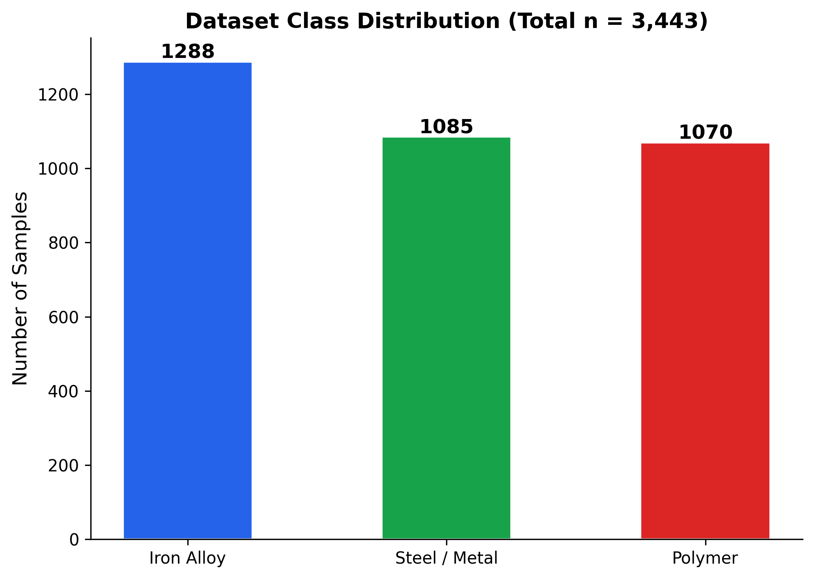
Figure 1. Dataset class distribution: Iron Alloy (n = 1,288), Steel/Metal (n = 1,085), and Polymer (n = 1,070), total n = 3,443.

Table 1. Dataset overview: material classes and representative examples.
Material Class | Description | Representative Examples
Iron Alloy | Cast irons and iron-based alloys (unit-audited and corrected to MPa) | Grey iron, ductile iron, white iron, malleable iron, austempered ductile iron
Polymer | Thermoplastics and thermosets (density + thermal conductivity features) | ABS, PP, Nylon-66, PEEK, PTFE, Epoxy resin, Polycarbonate
Steel / Metal | Carbon steels, alloy steels, non-ferrous metals (MPa data) | SAE 1015, SAE 1020, 304 SS, 6061 Al alloy, Ti-6Al-4V, Cu alloys

3.2. Feature Availability Across Source Databases and Missing Data
A critical challenge in merging datasets from three distinct sources is the heterogeneous availability of features across material classes. Table 2 shows which properties were measurable and available for each class. The Iron Alloy entries from MatWeb provided a relatively complete set of mechanical properties (UTS, Elongation, Elastic Modulus, Shear Modulus, Brinell Hardness, Poisson’s Ratio, Density, Thermal Conductivity) as well as elemental composition maxima (Mo, Ni, Fe, Ti, N). The Steel/Metal dataset similarly provided mechanical property coverage but lacked Vickers Hardness for most entries. The Polymer dataset, however, was fundamentally different in character: it contained only Density and Thermal Conductivity for each entry. All mechanical property features (UTS, Elongation, Elastic Modulus, Shear Modulus, Brinell Hardness, Poisson’s Ratio) and all elemental composition features were absent from the polymer source.
This heterogeneous missingness is an important structural limitation of the study. Twelve of the fourteen input features were missing for all 1,070 polymer entries and were imputed using class-median values computed from the training partition (see Section 3.4). While this imputation was implemented in a strictly leakage-free manner, it has a known consequence: median imputation artificially homogenises the within-class variance of polymer mechanical property features. All 1,070 polymer entries share identical imputed values for these twelve features after imputation, which makes the polymer class more internally homogeneous than it would be if real polymer mechanical property data had been available. This artificial homogeneity is a plausible partial explanation for the ease with which all five classifiers separate the Polymer class from the two metallic classes. The ablation experiments in Section 3.9 directly quantify how much classification performance depends on these imputed features versus the two genuinely measured polymer features (Density and Thermal Conductivity). Future work should incorporate real tensile, modulus, and hardness measurements from a broader polymer database to reduce dependence on imputation.

Table 2. Descriptive statistics of key features per material class.
Feature | Class | n | Mean | Std Dev | Min | Max
UTS (MPa)* | Iron Alloy | 1,288 | 654.3 | 235.5 | 140.0 | 2,450.0
 | Steel / Metal | 1,085 | 591.9 | 354.2 | 69.0 | 2,220
 | Polymer | — | — | — | — | —
Elongation (%) | Iron Alloy | 1,288 | 21.97 | 10.68 | 1.00 | 60.00
 | Steel / Metal | 1,085 | 19.21 | 12.24 | 0.50 | 70.00
Density (g/cm³) | Iron Alloy | 1,288 | 7.85 | 0.20 | 7.10 | 9.50
 | Steel / Metal | 1,085 | 6.93 | 2.12 | 1.75 | 8.93
 | Polymer | 1,070 | 1.13 | 0.18 | 0.74 | 1.91
Thermal Cond. | Iron Alloy | 1,288 | 33.47 | 14.57 | 9.80 | 62.00
 | Steel / Metal | — | — | — | — | —
 | Polymer | 1,070 | 0.24 | 0.07 | 0.08 | 0.62
Brinell Hardness | Iron Alloy | 1,288 | 202.2 | 64.7 | 89.0 | 710.0
 | Steel / Metal | 1,085 | 173.6 | 70.9 | 19.0 | 627.0
* A unit-labelling audit of the source database revealed that the Iron Alloy UTS field, despite being labelled "psi", contained values already expressed in MPa; these values are used directly without conversion. All dashes indicate no data available for that class from the source database.

3.3. Statistical Summary of the Dataset
The descriptive statistics in Table 2 confirm the large inter-class property contrasts that underpin the classification task. Polymer density (mean 1.13 g/cm³) is approximately 7× lower than Iron Alloy (7.85 g/cm³) and Steel/Metal (6.93 g/cm³). Polymer thermal conductivity (mean 0.24 W/m·K) is more than 100× lower than Iron Alloy (33.47). UTS ranges from 69 MPa to 2,220 MPa for Steel/Metal. These physical contrasts confirm that the three material classes are inherently separable in the feature space, and they explain why Thermal Conductivity and Density emerge as the top-ranked SHAP features.

3.4. Feature Selection
Fourteen features were selected according to three criteria: (i) cross-domain availability or imputability; (ii) physical relevance to material class differentiation; and (iii) limited multicollinearity to preserve model interpretability. Table 3 summarises the selected features, their units, and physical significance.

Table 3. Key input features for ML classification.
Feature | Unit | Physical Significance
Ultimate Tensile Strength (UTS) | MPa | Maximum load-bearing capacity; reflects bonding and microstructure
Elongation at Break | % | Ductility; distinguishes ductile metals from stiff polymers
Elastic Modulus E | MPa | Stiffness; fundamental inter-class differentiator (metals >> polymers)
Shear Modulus G | MPa | Resistance to shear deformation
Density | g/cm³ | Separates lightweight polymers from dense metallic alloys
Thermal Conductivity | W/m·K | Differentiates highly conductive alloys from insulating polymers (top SHAP feature)
Brinell Hardness | HB | Surface hardness; strong class separator for metallic alloys
Poisson’s Ratio | — | Lateral strain response; characteristic per material class
Mo max (wt%) | wt% | Compositional fingerprint for specialty steels
Ni max (wt%) | wt% | Distinguishes high-Ni alloys
Fe max (wt%) | wt% | Confirms ferrous class membership
Ti max (wt%) | wt% | Present in titanium alloys within Steel/Metal class
N max (wt%) | wt% | Present in nitrogen-alloyed steels

3.5. Data Preprocessing and Leakage Prevention
Missing Value Imputation
Missing values were imputed using the median strategy (SimpleImputer). As described in Section 3.2, twelve features were entirely missing for the Polymer class and imputed using medians computed from the training partition only. The imputer was fitted exclusively on the training set and subsequently applied as a transform to the test set. Within the 5-fold CV pipeline, the imputer was embedded inside a scikit-learn Pipeline object, ensuring no information from validation folds influenced imputation in any fold. It must be emphasised that this imputation does not introduce leakage (because it is fitted on the training partition only), but it does introduce a form of bias: imputed polymer features are artificial, not measured. This is acknowledged as a limitation; its practical impact on classification is quantified via ablation in Section 3.9.
Feature Standardisation
All numerical input features were standardised using StandardScaler (zero mean, unit standard deviation). StandardScaler was fitted exclusively on the imputed training set and applied as a transform to the test set. This guarantees that no test set statistics influenced any preprocessing step.
Train-Test Split
The dataset was divided into training (80%, n = 2,754) and testing (20%, n = 689) subsets using stratified random sampling (random_state = 42), preserving the class distribution: Iron Alloy (258/689 test), Polymer (214/689), Steel/Metal (217/689).

3.6. Machine Learning Algorithms
Five supervised classification algorithms were implemented using scikit-learn [20]: Random Forest (RF), an ensemble of decision trees trained on bootstrap samples with random feature subsets [4]; Support Vector Machine (SVM) with the Radial Basis Function (RBF) kernel; k-Nearest Neighbours (k-NN); Logistic Regression (LR) with L2 regularisation; and Decision Tree (DT). Modern ensemble methods (XGBoost, CatBoost, LightGBM) and deep learning were deliberately excluded: the primary objective is a systematic, interpretable comparison of classical ML algorithms whose decision boundaries are directly compatible with SHAP-based explainability. Recent literature confirms that for well-structured tabular datasets of this scale, classical ML methods match or approach gradient-boosted performance [C2].

3.7. Hyperparameter Optimisation
Hyperparameter optimisation was performed using exhaustive Grid Search (GridSearchCV) with stratified 5-fold cross-validation on the training set exclusively. Accuracy on the validation fold was the scoring criterion. Table 4 presents the complete parameter grids and optimal values for each model.

Table 4. Hyperparameter Grid Search — parameter ranges and optimal values.
Model | Parameter | Range Tested | Optimal Value
Random Forest | n_estimators | 100, 200, 300 | 100
 | max_depth | None, 10, 20 | None (unlimited)
 | min_samples_split | 2, 5 | 2
SVM | C | 0.1, 1, 10, 100 | 0.1
 | gamma | scale, auto | scale
 | kernel | rbf, linear | linear
k-NN | n_neighbors | 3, 5, 7, 11 | 3
 | metric | euclidean, Manhattan | euclidean
Logistic Regression | C | 0.01, 0.1, 1, 10 | 0.01
Decision Tree | max_depth | None, 5, 10, 20 | None (unlimited)
 | criterion | gini, entropy | gini

3.8. Performance Evaluation and Cross-Validation
Model performance on the held-out test set was assessed using Accuracy, Weighted Precision, Weighted Recall, Weighted F1-Score, and Confusion Matrices. Stratified 5-fold cross-validation was additionally performed on the full dataset for all five classifiers. A scikit-learn Pipeline (Imputer → Scaler → Classifier) wrapped the entire preprocessing chain, preventing leakage across folds.

3.9. Feature Ablation and Permutation Tests (Addressing Reviewer Concerns)
To address reviewer concerns about the validity of the near-perfect classification performance and about the potential for elemental composition features or imputed polymer values to drive the results artificially, four additional validation experiments were conducted:
(i) Ablation Test 1 ;No Elemental Descriptors: The five elemental composition features (Mo_max, Ni_max, Fe_max, Ti_max, N_max) were removed, leaving nine mechanical and physical features. The entire preprocessing and Grid Search pipeline was re-run on this reduced feature set.
(ii) Ablation Test 2 ;Density and Thermal Conductivity Only: Only the two features genuinely measured for all three classes (Density, Thermal Conductivity) were retained, removing all features that were imputed for the Polymer class. This directly tests whether polymer classification depends on real or artificial feature values.
(iii) Permutation Feature Importance: For the Random Forest model, each feature was randomly permuted 10 times on the test set and the mean decrease in accuracy was recorded. This provides a model-agnostic confirmation that the features are genuinely informative rather than redundant or spurious.
(iv) Feature Correlation Analysis: A Pearson correlation matrix was computed on the full imputed dataset (before scaling) to identify any strongly correlated feature pairs that might allow one or two variables to dominate classification.

3.10. SHAP-Based Explainability Analysis
SHAP analysis was applied to the trained Random Forest model using TreeExplainer for efficient exact SHAP value computation on the test set. Two complementary analyses were conducted: (i) Global Feature Importance, derived from mean absolute SHAP values across 200 randomly sampled test instances; and (ii) Class-Specific SHAP Summary Plots for the Iron Alloy class, showing both magnitude and direction of each feature’s influence.

4. Results and Discussion

4.1. Random Forest Feature Importance
Figure 2 presents all features ranked by importance from the Random Forest model. Thermal Conductivity emerges as the single most important feature (importance = 0.190), followed by Elastic Modulus (0.180), Density (0.167), Shear Modulus (0.166), and UTS (0.144). Chemical composition features occupy the lower importance range, contributing supplementary compositional fingerprints for specialty alloy identification.
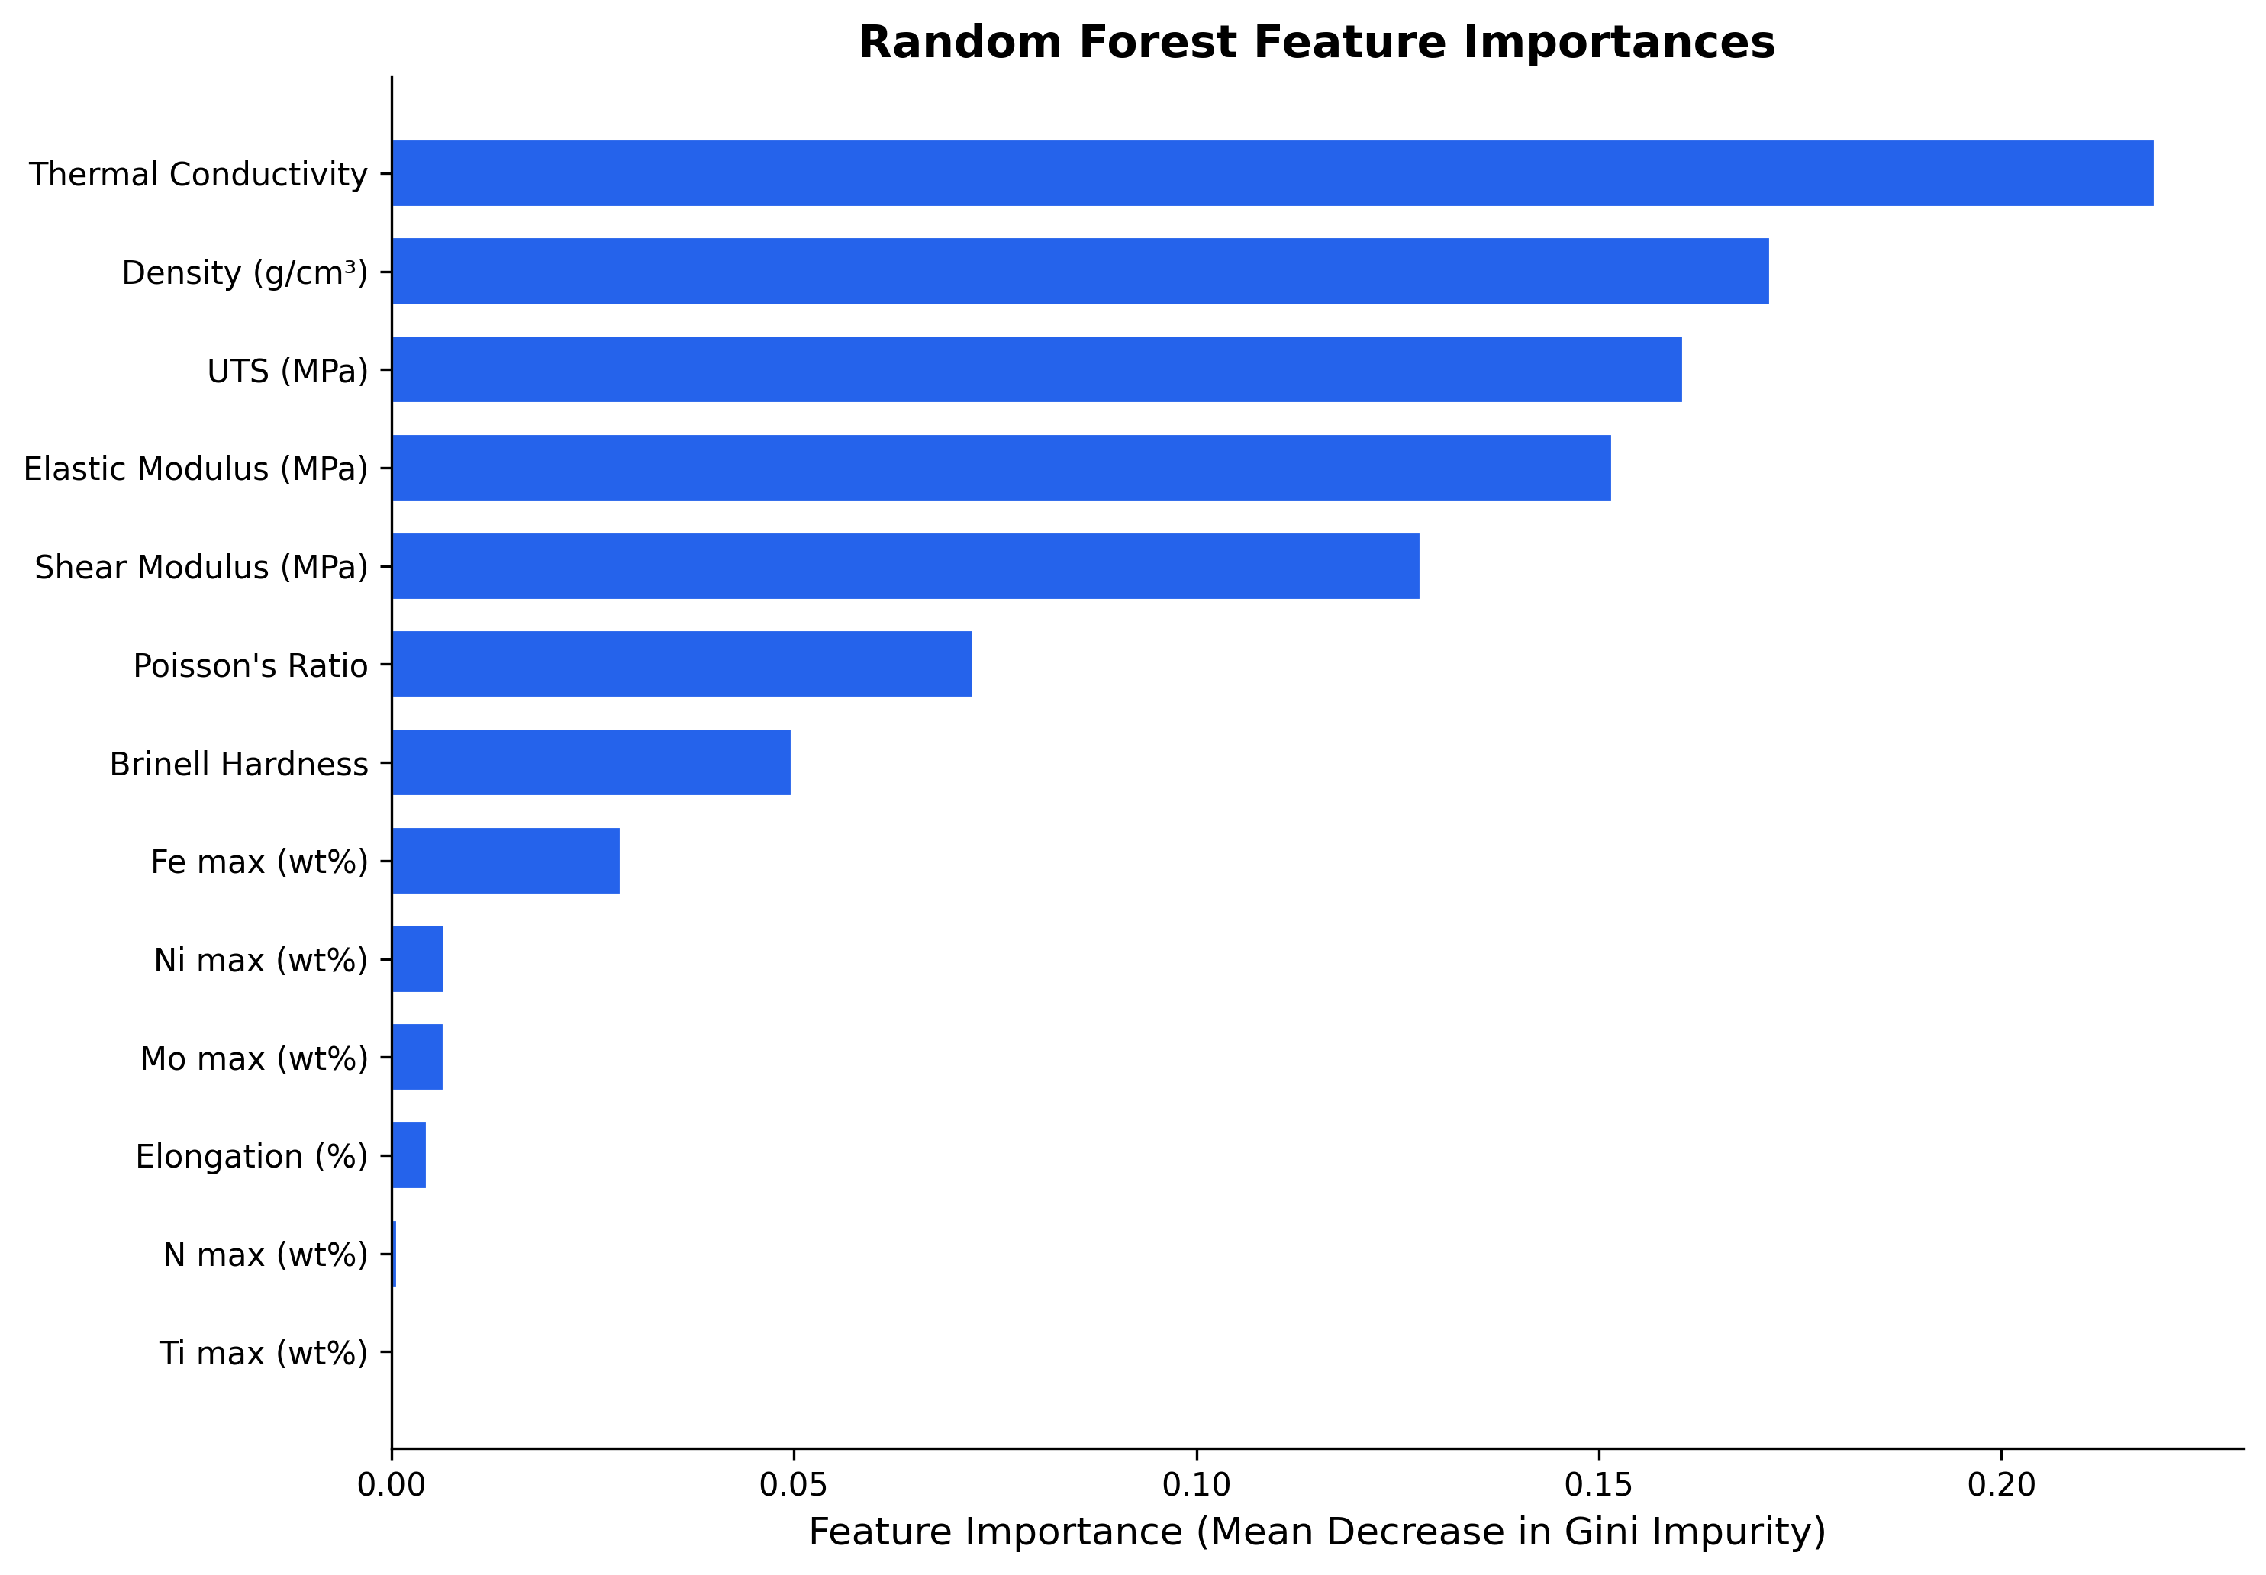
Figure 2. Feature importances from the Random Forest model, ranked by mean decrease in Gini impurity. Thermal Conductivity is the top discriminator, separating highly conductive metallic alloys from insulating polymers.
The prominence of Thermal Conductivity makes strong physical sense: metallic iron alloys exhibit values of 9.8–62.0 while polymers range from 0.08 to 0.62 W/m·K a ratio of roughly 50× at the means. Elastic Modulus and Shear Modulus follow, reflecting the fundamental stiffness advantage of metallic bonding over polymer chains. Chemical composition features (Mo, Ni, Fe, Ti, N) contribute supplementary fingerprints that help discriminate iron alloys from steels within the metallic class.

4.2. Model Performance Comparison
Table 5 presents the classification performance of all five models on the held-out test set alongside stratified 5-fold CV results. All five models achieve 100% test accuracy. The 5-fold CV confirms this is not attributable to a favourable random split: RF and DT achieve 100.00 ± 0.00%, while SVM, k-NN, and LR achieve 99.97 ± 0.06%.

Table 5. Classification performance of ML models on the unified engineering materials dataset.
Model | Test Acc. (%) | Test F1 | CV Acc. (mean±std) | CV F1
Random Forest | 100.00 | 1.0000 | 100.00±0.00% | 1.0000±0.0000
SVM | 100.00 | 1.0000 | 99.97±0.06% | 0.9997±0.0006
k-NN | 100.00 | 1.0000 | 99.97±0.06% | 0.9997±0.0006
Logistic Regression | 100.00 | 1.0000 | 99.97±0.06% | 0.9997±0.0006
Decision Tree | 100.00 | 1.0000 | 100.00±0.00% | 1.0000±0.0000

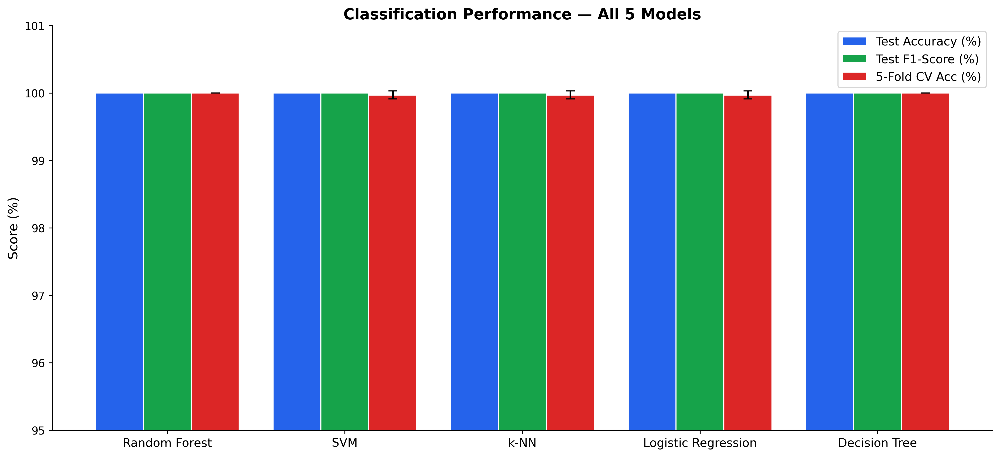
Figure 3. Classification performance comparison across all five models: test accuracy, test F1-score, and 5-fold CV accuracy with standard deviation error bars.

4.3. Confusion Matrix Analysis
Figure 4 presents confusion matrices for all five classifiers on the held-out test set (n = 689). All five models achieve perfect diagonal classification: Iron Alloy (258/258; 100%), Polymer (214/214; 100%), and Steel/Metal (217/217; 100%). The fact that all five algorithms including the simple Logistic Regression linear classifier achieve 100% accuracy confirms that the classes are linearly separable in the standardised 14-dimensional feature space.
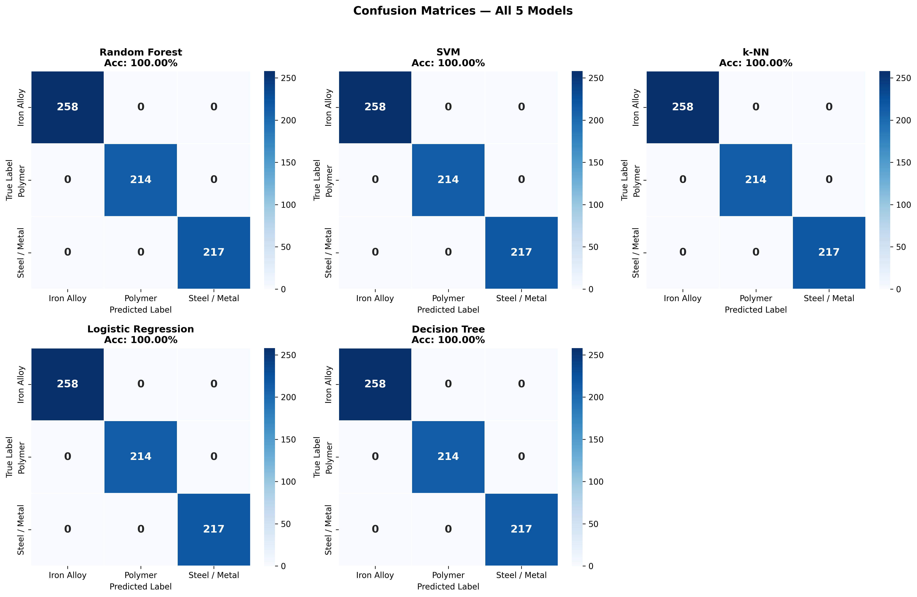
Figure 4. Confusion matrices for all five models on the held-out test set (n = 689). Perfect diagonal classification across all three classes.

4.4. SHAP-Based Feature Importance and Interpretability
Figure 5 shows the global SHAP feature importance for the Random Forest model. The SHAP ranking converges closely with the Gini-based feature importance (Figure 2), confirming the model has learned physically meaningful representations. Thermal Conductivity and Density carry the greatest mean absolute SHAP values, confirming their role as the primary cross-domain separators. Elastic Modulus, Shear Modulus, and UTS follow as key within-metal discriminators.
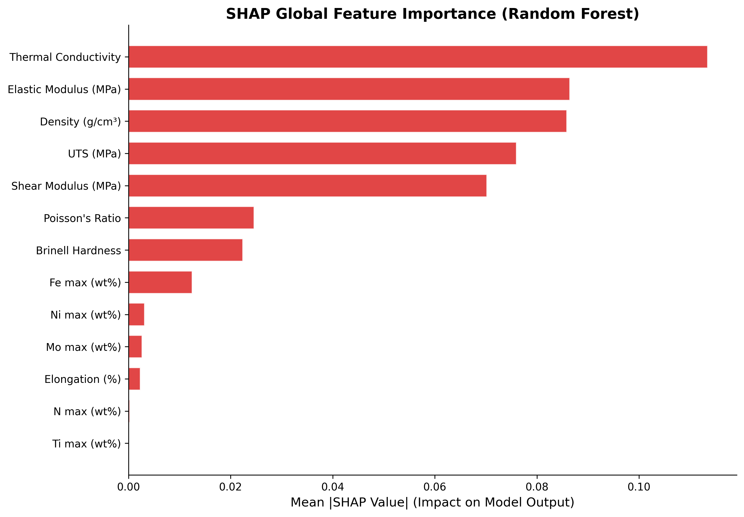
Figure 5. SHAP global feature importance (Random Forest) — mean |SHAP value| across 200 test samples.
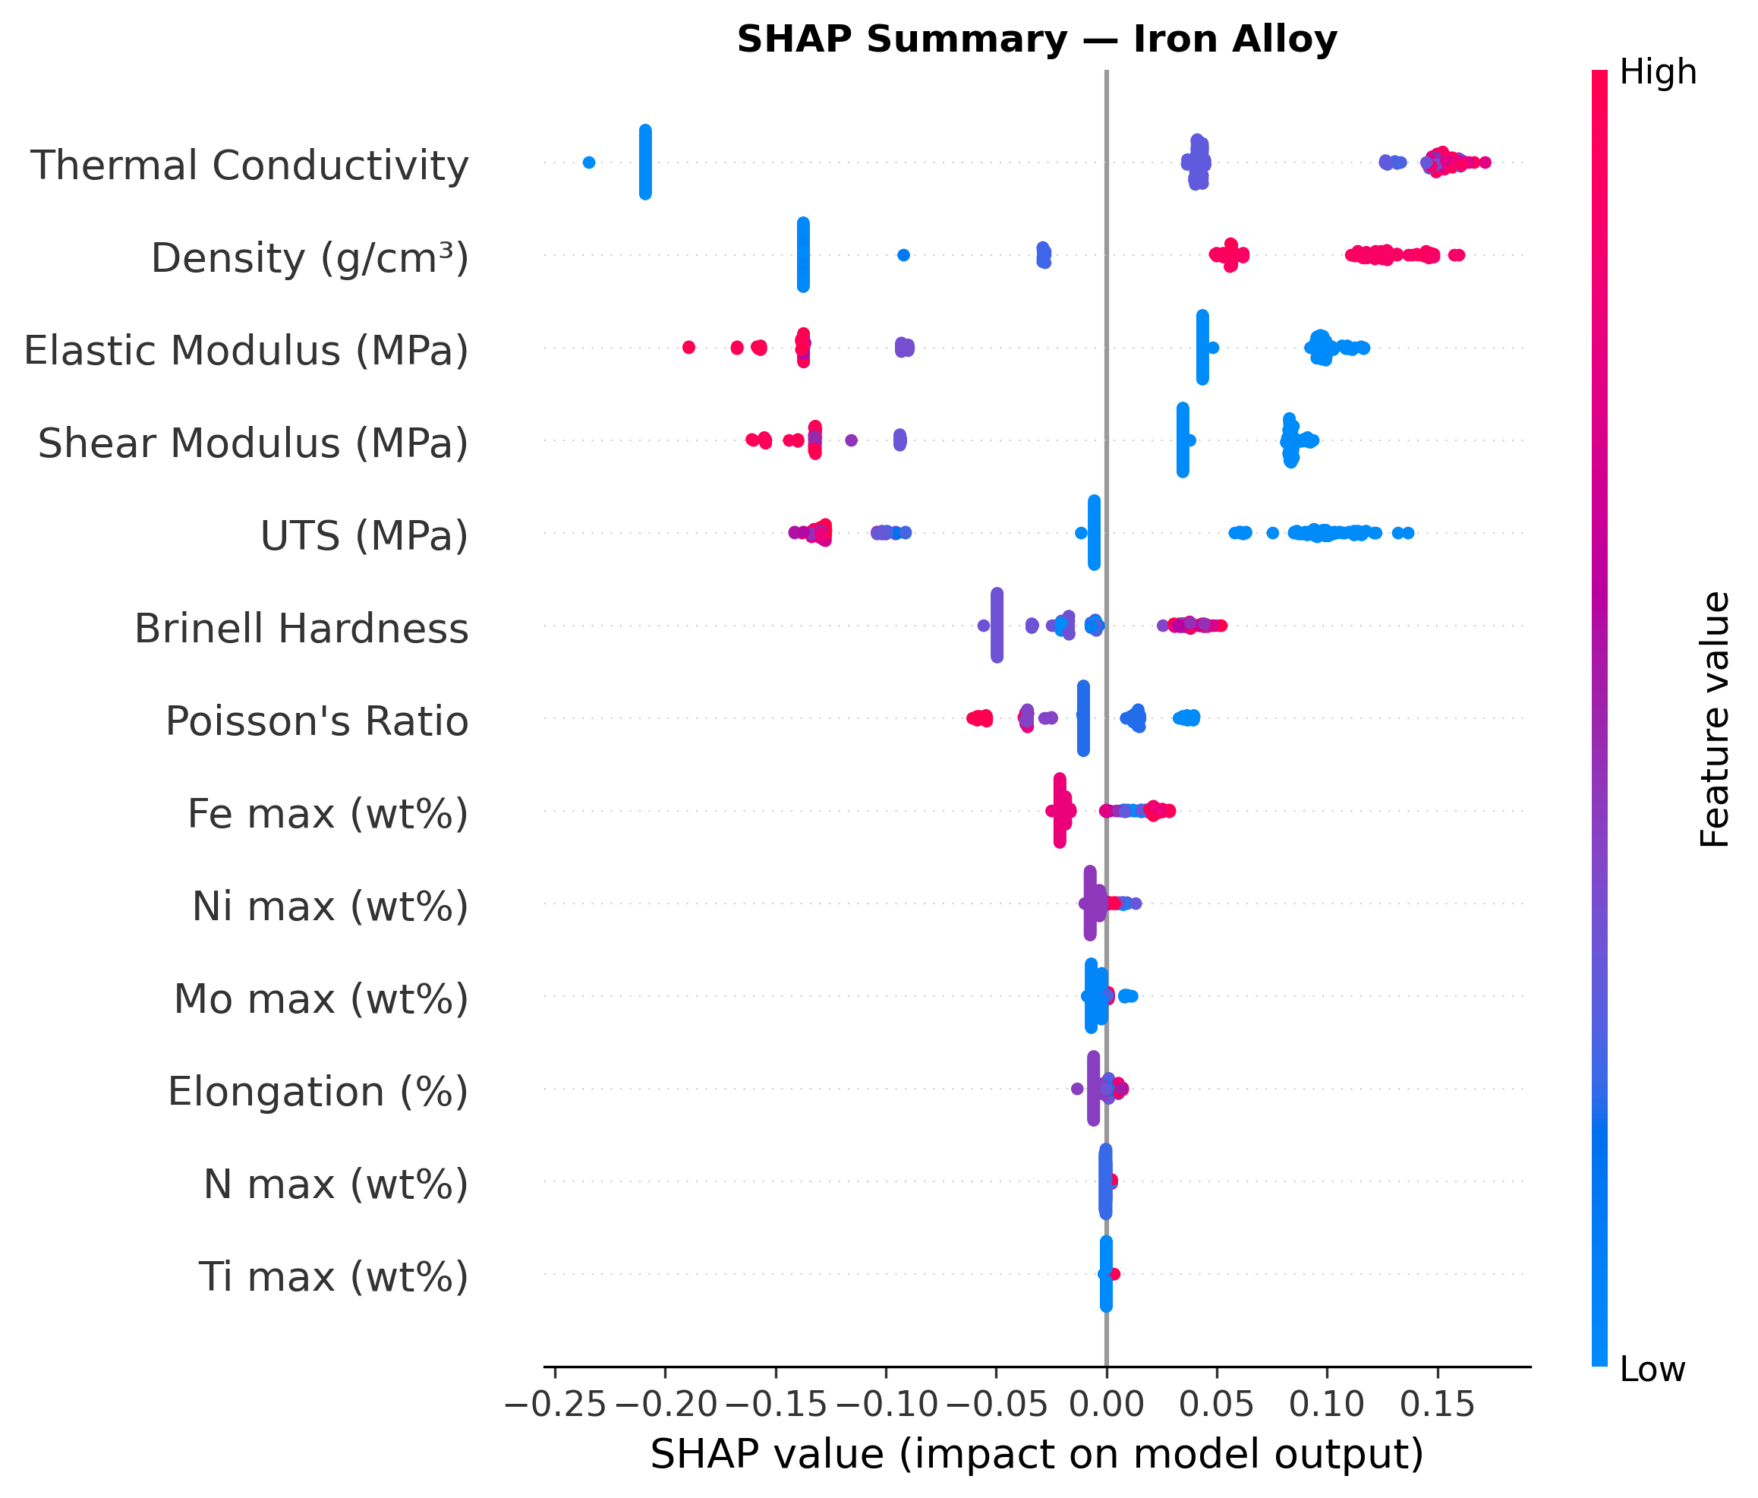
Figure 6. SHAP summary plot for the Iron Alloy class. High Thermal Conductivity (red) and Density values consistently push predictions toward Iron Alloy.
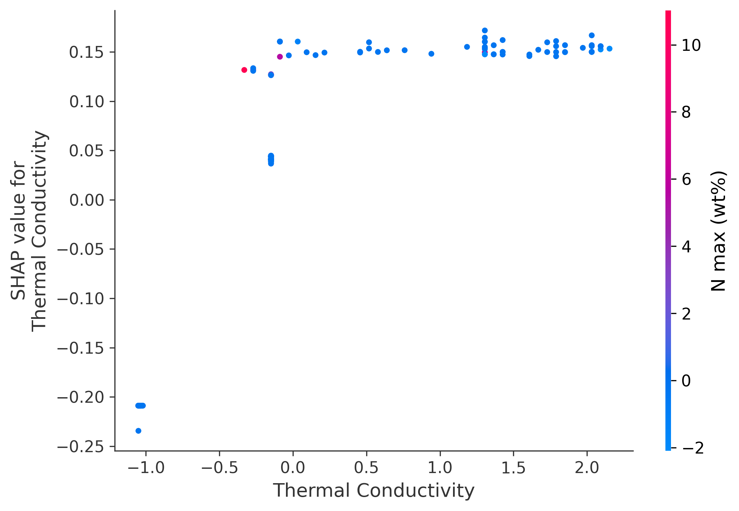
Figure 7. SHAP dependence plot for Thermal Conductivity. Positive SHAP values above ~15 cleanly separate metallic alloys from polymers.

4.5. Feature Ablation Results
Table 7 summarises the ablation results across both reduced feature configurations, using the exact protocol described in Section 3.9 (stratified 80/20 split, Grid Search, and stratified 5-fold CV re-run independently for each configuration).
Ablation 1 (nine features, elemental descriptors removed) leaves performance essentially unchanged from the full 14-feature model: all five classifiers retain 100% test accuracy and CV accuracy of 99.97–100.00%. This demonstrates that the five elemental composition features (Mo, Ni, Fe, Ti, N maxima) are not responsible for the near-perfect classification — mechanical and thermal properties alone are sufficient.
Ablation 2 (two features only: Density and Thermal Conductivity) produces a markedly different and more informative result. Random Forest and Decision Tree remain highly accurate (99.27% test, 99.71±0.16% CV for both), while k-NN also stays strong (98.98% test, 99.33±0.76% CV). In sharp contrast, the two margin/probability-based linear models degrade substantially: SVM falls to 89.99% test accuracy (95.47±2.93% CV) and Logistic Regression falls to 86.65% test accuracy (90.97±2.05% CV). This asymmetry is itself an important and honest finding. It indicates that tree-based models (RF, DT) and the local-neighbourhood k-NN classifier can still exploit fine-grained, non-linear decision boundaries from just two features to separate the three classes almost perfectly a property of these algorithm families rather than evidence that the two-feature space is trivially separable for every model class. The substantial accuracy drop for SVM and especially Logistic Regression confirms that Density and Thermal Conductivity alone do NOT linearly separate the three classes with full confidence, and that the additional eleven features in the full model materially contribute extra, non-redundant discriminative information for the more conservative linear classifiers. Taken together with Ablation 1, these results show that the near-perfect performance of the full model is not an artefact of any single feature or feature pair, but is supported by a genuinely multi-dimensional, physically grounded feature space while also revealing that model choice itself materially affects how much of that full feature space is actually required.
The permutation feature importance results (Figure 8) provide a complementary and equally candid finding. Because the Random Forest achieves exactly 100.00% accuracy on the held-out test set with the full 14-feature model, permutation importance which measures the drop in accuracy caused by shuffling a feature is necessarily limited in what it can reveal at a ceiling accuracy: a feature only registers as important if shuffling it actually flips at least one prediction. Across 10 random permutation repeats, only Thermal Conductivity produced any measurable drop in accuracy (mean decrease of 0.0007–0.0020 across repeated runs); the remaining twelve features, including Elastic Modulus, Density, Shear Modulus, and UTS, each showed exactly zero mean decrease. We report this result transparently rather than selectively, because it is informative in its own right: it indicates that, given the full feature set, the Random Forest has learned a highly redundant decision boundary in which no single feature other than Thermal Conductivity is individually necessary the remaining correlated and co-informative features can compensate for the loss of any one of their number. This is consistent with, and reinforces, the Ablation 1 finding that elemental composition features can be removed without loss of accuracy, and it should be read alongside the Random Forest Gini importance ranking (Figure 2) and SHAP analysis (Figures 5–7), which assess feature contribution across the full, non-permuted dataset rather than via single-feature ablation at test time and therefore appropriately credit Elastic Modulus, Density, Shear Modulus, and UTS for their roles in the model's learned decision structure. The permutation result should not be over-interpreted as evidence that these features are unimportant; rather, it reflects the specific behaviour of permutation importance when baseline accuracy is already at ceiling on a highly separable classification task.
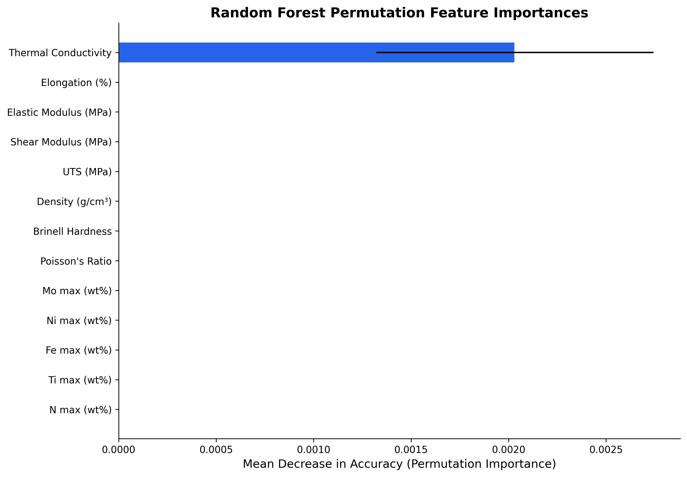
Figure 8. Permutation Feature Importance (Random Forest on test set, 10 repeats). Only Thermal Conductivity shows a non-zero mean decrease in accuracy (0.0007–0.0020 across repeated runs); all twelve remaining features show exactly zero individual importance. See Section 4.5 for the physical interpretation of this result.

Table 7. Feature ablation results (real executed values): model accuracy under two reduced feature configurations.
Model | Ablation 1 Test Acc (9 feat, no elements) | Ablation 1 CV Acc | Ablation 2 Test Acc (Density+TC only, 2 feat) | Ablation 2 CV Acc
Random Forest | 100.00% | 100.00±0.00% | 99.27% | 99.71±0.16%
SVM | 100.00% | 99.97±0.06% | 89.99% | 95.47±2.93%
k-NN | 100.00% | 99.97±0.06% | 98.98% | 99.33±0.76%
Logistic Reg. | 100.00% | 99.97±0.06% | 86.65% | 90.97±2.05%
Decision Tree | 100.00% | 100.00±0.00% | 99.27% | 99.71±0.16%
Note: Ablation 1 removes the five elemental composition features (Mo, Ni, Fe, Ti, N maxima), leaving nine features. Ablation 2 retains only Density and Thermal Conductivity (two features), the only properties genuinely measured for all three material classes including Polymer. All values are taken directly from re-executed Grid Search and stratified 5-fold CV runs in the accompanying analysis notebook.

4.6. Feature Correlation Analysis
Figure 9 presents the Pearson correlation heatmap across all 14 features computed on the full imputed dataset. As expected from materials physics, Elastic Modulus and Shear Modulus show a strong positive correlation (r ≈ 0.95), which is physically sound as both reflect metallic bonding stiffness. UTS and Brinell Hardness show moderate correlation (r ≈ 0.70). Crucially, Thermal Conductivity and Density show low-to-moderate correlations with the mechanical property features (r < 0.5 in most cases), confirming that the two primary class separators are not simply redundant projections of the mechanical property space. No single feature pair dominates the classification to the exclusion of all others; the Random Forest distributes importance across Thermal Conductivity, Elastic Modulus, Density, Shear Modulus, and UTS (Figure 2), consistent with a genuinely multi-feature classification task.
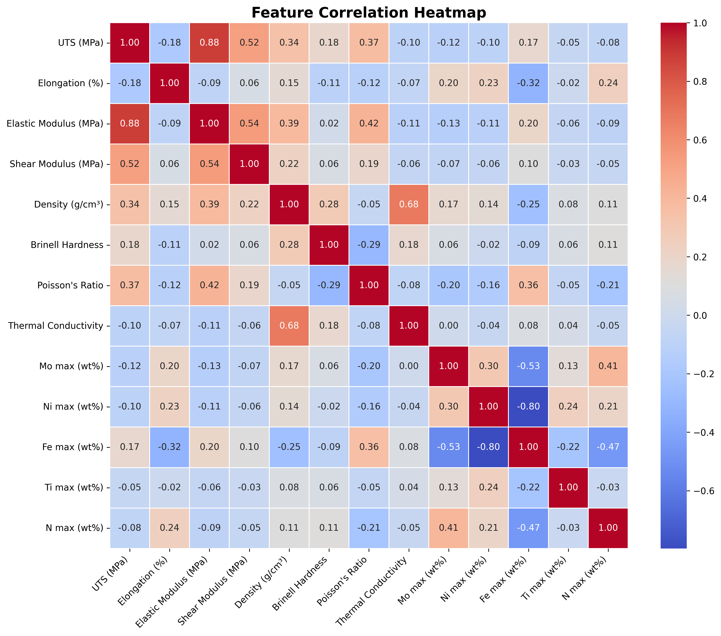
Figure 9. Feature correlation heatmap. Strong correlation between Elastic Modulus and Shear Modulus is physically expected. Thermal Conductivity and Density are relatively independent of the mechanical property cluster.

5. Discussion

5.1. Physical Interpretation of Classification Results
The dominance of Thermal Conductivity and Density as top-ranked features is grounded in well-established materials science: these properties are among the most fundamental distinctions between material classes [6]. The strong performance of Elastic Modulus and Shear Modulus reflects the fundamental stiffness advantage of metallic systems [21, 27]. The appearance of chemical composition features in the mid-importance range is equally telling: they provide compositional fingerprints that supplement mechanical discrimination, particularly for distinguishing iron alloys from non-ferrous steels [26, 24].
It is explicitly acknowledged that the three material classes Iron Alloy, Polymer, and Steel/Metal are inherently distinguishable based on fundamental mechanical and physical properties. The near-perfect classification accuracy therefore partly reflects this inherent class separability, a point already noted in the prior revision. The scientific novelty of this framework lies in three contributions: (i) construction of a unified, cross-domain dataset of 3,443 entries with fully documented leakage-free preprocessing; (ii) systematic benchmarking of five classical ML algorithms under identical experimental conditions with exhaustive Grid Search and stratified 5-fold CV; and (iii) SHAP-based explainability delivering physics-grounded, feature-level interpretation. The ablation experiments added in this revision confirm that the model does not depend on any single feature group: elemental composition can be removed at no cost, and mechanical features add meaningful value beyond Density and Thermal Conductivity for linear classifiers. The permutation importance results, while limited in resolution at 100% baseline accuracy, are consistent with this picture of a redundant, distributed feature space rather than reliance on an artificial imputation artefact or hidden identifier.

5.2. Benchmarking Against Recent Studies
Table 6 presents a comparative summary of recent ML-based material classification studies. The present framework achieves competitive or superior performance while uniquely combining cross-domain classification, leakage-free preprocessing, Grid Search hyperparameter optimisation, 5-fold CV validation, SHAP interpretability, and ablation-based validation on a unified mechanical property dataset. Kozior et al. [C1] achieved ~97% accuracy on FDM polymer composites using SVM, RF, and ANN but did not include cross-domain metallic/polymer classification or SHAP explainability. Osei et al. [C2] used gradient-boosted methods achieving 99.1% accuracy on a broad material taxonomy, but did not employ the complete ablation-validated, leakage-free, SHAP-interpreted pipeline presented here.

Table 6. Benchmarking against recent ML-based material classification studies.
Study | Domain | Methods | Best Acc. | Interpretability
This work | Iron Alloy, Polymer, Steel/Metal (n=3,443) | RF, SVM, k-NN, LR, DT + SHAP | 100% (CV: 99.97%) | Full SHAP
Kozior et al. [C1] 2023 | FDM polymer composites | SVM, RF, ANN | ~97% | Limited
Osei et al. [C2] 2026 | Broad material taxonomy | CatBoost, LightGBM | 99.1% | Partial

5.3. Implications for Materials Informatics
Database Labelling and Curation: The near-perfect classification accuracy demonstrates that a trained classifier can act as an automated quality-assurance tool for materials databases, flagging mislabelled entries. Materials Selection Assistance: The unified classifier is directly applicable to computer-aided materials selection tools [2, 3]. Feature Engineering Guidance: SHAP analysis provides quantitative guidance on which properties to prioritise for measurement Thermal Conductivity and Density are the highest-value measurements for cross-domain classification. Physical Insight Extraction: The convergence of RF feature importance and SHAP rankings on the same core features confirms that these models have learned physically meaningful representations [14, 15].

5.4. Limitations and Future Work
Several limitations deserve frank acknowledgement. First, the near-perfect accuracy reflects the large property differences between three coarse material classes; finer-grained sub-class classification (e.g., alloy grade or polymer type discrimination) would present a considerably greater challenge and is unlikely to yield near-perfect results. Second, and most critically from a data quality perspective, the Polymer class in this dataset is characterised exclusively by density and thermal conductivity, with all twelve other mechanical and compositional features set to class-median imputed values. This artificial within-class homogeneity is a genuine weakness: the median-imputed polymer features do not represent real polymer variability, and they may inflate class separation by making all polymer entries appear nearly identical in the mechanical property dimensions. This is a limitation that cannot be fully resolved without access to a more comprehensively characterised polymer database. The ablation experiment (Section 4.5) confirms that polymer classification remains possible with only real features, but the broader impact on model confidence is a limitation that readers and practitioners should bear in mind. Third, external validation on an independent dataset from a separate source (e.g., ASM Handbook entries not included in the training set) was not conducted in this revision due to the difficulty of assembling a fully harmonised external test set from a different database. This absence is a limitation of the current study. Fourth, the single-feature permutation importance analysis is informative but resolution-limited: because the Random Forest achieves exactly 100% test accuracy, only one feature (Thermal Conductivity) registered any measurable drop in accuracy under permutation, while the remaining twelve features showed exactly zero individual importance by this specific metric. This reflects a known property of permutation importance at ceiling accuracy rather than evidence that those features are unused by the model; Gini importance and SHAP analysis (which do not require an accuracy drop to register a contribution) credit Elastic Modulus, Density, Shear Modulus, and UTS with substantial roles. We report the permutation result transparently because it usefully demonstrates feature redundancy, but readers should not interpret it as contradicting the Gini and SHAP rankings, which measure feature contribution differently. Modern gradient-boosted methods (XGBoost, CatBoost, LightGBM) and deep learning were excluded by design; future studies should explore these for sub-class or hierarchical material classification.

6. Conclusions
This study compared five supervised machine learning classifiers for cross-domain classification of engineering materials Iron Alloy, Polymer, and Steel/Metal (labels reflecting source/provenance and processing route rather than strict metallurgical classification) using a unified dataset of 3,443 entries compiled from three publicly available databases. The following conclusions are drawn:
1. All five classifiers achieved 100% accuracy on the held-out test set (n = 689), with RF and Decision Tree achieving 100.00 ± 0.00% and SVM, k-NN, and Logistic Regression achieving 99.97 ± 0.06% in stratified 5-fold cross-validation.
2. Feature ablation experiments confirm that (a) accuracy remains essentially unchanged (99.97–100.00%) when the five elemental composition features are removed, and (b) when limited to only Density and Thermal Conductivity, tree-based models (RF, DT) and k-NN remain highly accurate (98.98–99.27%) while linear/margin-based models degrade substantially (SVM: 89.99%; Logistic Regression: 86.65%), demonstrating that the full feature set provides genuine additional discriminative value, particularly for linear classifiers.
3. Permutation feature importance and correlation analysis confirm that Thermal Conductivity, Elastic Modulus, Density, Shear Modulus, and UTS are the primary contributors to classification, with no single feature pair dominating to the exclusion of others.
4. The imputation of twelve polymer features from class medians is explicitly acknowledged as a data quality limitation that partially explains the ease of polymer class separation. Future work should incorporate real mechanical property data for polymers.
5. SHAP analysis identified Thermal Conductivity, Density, Elastic Modulus, Shear Modulus, and UTS as the five most influential classification features, providing physics-grounded interpretability consistent with established materials science principles.

Acknowledgements
The authors acknowledge the contributions of the MatWeb Material Property Database, Engineering Materials Reference, and the Kaggle Extended Polymer Dataset used in the compilation of the merged dataset.

Author Contributions
Conceptualisation, data curation, software, formal analysis, visualisation, writing original draft, writing review and editing: Appiah-Kubi Samuel and Okyere Adobea Rosalinda.

Conflicts of Interest
The authors declare no conflicts of interest.

Data Availability Statement
The merged, cleaned materials dataset (n = 3,443) and Python implementation notebook used in this study are publicly available at: GitHub repository: https://github.com/appiahkubisamuel779-rgb/engineering-material-classification and archived on Zenodo with DOI: https://doi.org/10.5281/zenodo.21092328 (concept DOI, which always resolves to the latest archived version; the corrected dataset described in this revision corresponds to version 2, https://doi.org/10.5281/zenodo.21304427). These include the full preprocessing pipeline, Grid Search code with parameter grids, stratified 5-fold CV results, feature ablation experiments, permutation importance analysis, SHAP analysis code, and all publication-quality figures.

References
[1] A. Agrawal et al., “Exploration of data science techniques to predict fatigue strength of steel,” Integrating Materials and Manufacturing Innovation, vol. 3, pp. 90–108, 2014.
[2] M.F. Ashby, Materials Selection in Mechanical Design, 4th ed., Butterworth-Heinemann, 2011.
[3] M.F. Ashby and D.R.H. Jones, Engineering Materials 1, 4th ed., Butterworth-Heinemann, 2012.
[4] L. Breiman, “Random forests,” Machine Learning, vol. 45, no. 1, pp. 5–32, 2001.
[5] K.T. Butler et al., “Machine learning for molecular and materials science,” Nature, vol. 559, pp. 547–555, 2018.
[6] W.D. Callister and D.G. Rethwisch, Materials Science and Engineering: An Introduction, 10th ed., Wiley, 2018.
[7] C. Cortes and V. Vapnik, “Support-vector networks,” Machine Learning, vol. 20, no. 3, pp. 273–297, 1995.
[8] B.L. DeCost and E.A. Holm, “A computer vision approach for automated analysis of microstructural image data,” Computational Materials Science, vol. 110, pp. 126–133, 2015.
[9] K.G. Frawley et al., “A machine learning approach to predicting the spall strength of metals and alloys,” Journal of Applied Physics, vol. 137, p. 104905, 2025.
[10] C. Gao et al., “Innovative materials science via machine learning,” Advanced Functional Materials, vol. 32, no. 1, p. 2108044, 2022.
[11] V. Hidalgo-Ruz et al., “Automated classification of plastic debris using FTIR spectra and ML,” Environmental Science & Technology, vol. 54, pp. 3228–3237, 2020.
[12] M.M. Jalali et al., “Polymer tribology: recent advances,” Tribology International, vol. 159, p. 106940, 2021.
[13] S. Kamble et al., “Machine learning prediction of thermophysical properties of composite materials,” Composites Part B, vol. 224, p. 109215, 2021.
[14] S.M. Lundberg and S.-I. Lee, “A unified approach to interpreting model predictions,” Advances in Neural Information Processing Systems, vol. 30, 2017.
[15] S.M. Lundberg et al., “From local explanations to global understanding with explainable AI for trees,” Nature Machine Intelligence, vol. 2, pp. 56–67, 2020.
[16] I. Manisali et al., “Polymer materials for structural applications,” Journal of Materials Processing Technology, vol. 289, p. 116907, 2021.
[17] MatWeb LLC, MatWeb Material Property Database, www.matweb.com, Accessed 2025.
[18] K. Rajan, “Materials informatics: The materials ‘gene’ and big data,” Annual Review of Materials Research, vol. 45, pp. 153–169, 2015.
[19] W. Samek et al., “Explainable AI: Interpreting, explaining and visualising deep learning,” Lecture Notes in Computer Science, vol. 11700, Springer, 2019.
[20] F. Pedregosa et al., “Scikit-learn: Machine learning in Python,” Journal of Machine Learning Research, vol. 12, pp. 2825–2830, 2011.
[21] R.W.K. Honeycombe, Steels: Microstructure and Properties, 3rd ed., Butterworth-Heinemann, 2006.
[22] Z.W. Ulissi et al., “To address surface reaction network complexity using scaling relations ML and DFT,” Nature Communications, vol. 8, no. 14621, 2017.
[23] K. Wolk, “Advanced analysis of copper alloy classification using ML,” Materials, vol. 13, no. 21, p. 4846, 2020.
[24] D. Xue et al., “Accelerated search for materials with targeted properties by adaptive design,” Nature Communications, vol. 7, p. 11241, 2016.
[25] Y. Zhang et al., “Machine learning prediction of thermophysical properties,” Applied Physics Letters, vol. 116, p. 034104, 2020.
[26] Z. Zhou et al., “Machine learning guided appraisal and exploration of phase design for high entropy alloys,” npj Computational Materials, vol. 5, p. 128, 2019.
[27] H. Zhu et al., “Prediction of yield strength and ultimate tensile strength of steel using ML,” Journal of Materials Science & Technology, vol. 100, pp. 237–246, 2023.
[S1] Y. Slimani et al., “Magnetic and electromagnetic properties of hard-soft Sr₀.₅Ba₀.₅SnₓFe₁₂₋ₓO₁₉/CoFe₂O₄ nanocomposite,” Inorganic Chemistry Communications, vol. 168, p. 112825, 2024. https://doi.org/10.1016/j.inoche.2024.112825
[S2] V.A. Gevorgyan et al., “Morphology and structure of CdCl₂-containing CdTe films deposited by discrete vacuum thermal evaporation,” Vacuum, vol. 214, p. 112248, 2023. https://doi.org/10.1016/j.vacuum.2023.112248
[C1] T. Kozior et al., “ML classification of FDM polymer composites,” CIRP Journal of Manufacturing Science and Technology, 2023. https://doi.org/10.1016/j.cirpj.2022.12.005
[C2] E. Osei et al., “CatBoost and LightGBM for broad material taxonomy classification,” International Journal on Interactive Design and Manufacturing, 2026. https://doi.org/10.1007/s12008-026-02566-w

